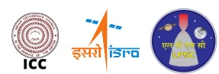 30th National Conference on Cryogenics and Superconductivity, 2026
7-9 December 2026, LPSC-ISRO, Valiamala, Thiruvananthapuram

Guidelines for Preparing the Extended Abstract (Times New Roman, 14pt Bold, Capitalise Each Word)

Author 1ª, Author 2^{b} (10 Pt Bold, Times New Roman)
a - Affiliation, b - Affiliation (Times New Roman, 8pt, Italics)
E-mail: communicatingauthor@some.com(Times New Roman, 8pt, Italics)

I Introduction
This article presents detailed instructions for the preparation of Extended Abstract for the NSCS-30 at LPSC-ISRO, Valiamala, Thiruvananthapuram. The extended abstract (max. ONE PAGE) shall be prepared considering the sections shown in this template. Use ‘Times New Roman” font consistently. All section headings shall be of 10 pt bold. All Subsection headings shall be of 9 pt bold. Body text shall be of 10 pt normal. Kindly follow the guidelines strictly for the preparation of the extended abstracts. The abstract shall be submitted under any one of the conference sub-themes. Please avoid reporting of routine trends, routine characterization as the main accomplishment of the study. The novelty and its impact on cryogenic and superconductivity knowledge database need to be brought forth. [1].

II Motivation and Objective
This part of the abstract shall be provided with the motivation for the work and objective of the paper.

III Methodology
This part shall discuss about the methodology adopted in the study for achieving the objective. Details about the various stages in the methodology shall be provided in brief. The extended abstract may have one table, and/or one figure indicating methodology and/or typical results. Data in the form of a table should be reported in the format pertaining to Table 1. Format of all figures should be as per Fig. 1.
Table-1 Physical properties of sands

Soil | D60  (mm) | D30  (mm) | D10  (mm) | Cu | Cc | μo
Sand1 | 0.25 | 0.20 | 0.16 | 0.56 | 1.00 | 33
Sand2 | 0.22 | 0.19 | 0.13 | 1.47 | 1.09 | 35

IV Important Outcomes
Important outcomes of the study shall be presented in this section. The extended abstract shall be of maximum one page (A4 size, with 0.5 cm (0.019685') top & bottom margins, 1.0 cm (0.393701') left and right margins) as per the format shown here. One or two important references shall be cited and listed in reference section. Figure Labels: Use 9 point Times New Roman for Figure labels. Use the abbreviation “Fig. 1.” even at the beginning of a sentence. Figure captions should be below the figures; table heads should appear above the tables. Insert figures and tables after they are cited in the text.

V Conclusion
Main conclusions highlighting the novelty of the work have to be briefly mentioned in this section. Pdf version of the extended abstract shall be uploaded to the conference website using author registration/login. Each abstract will be given a unique number which shall be used for further communication. The abstract will be reviewed and the authors of the accepted abstracts will be requested to submit full length paper.
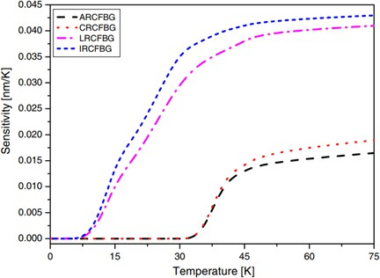

Fig. 1. Sensitivity of different metal-coated FBG sensors
References style format must follow the style Author name, title, Publisher/journal/proceeding name, volume number, (year), pages. References run consecutively through the paper with [] brackets. Authors should ensure that all references are cited in the text and vice versa. See the examples of article in conference proceedings [1], article in journal [2], conference proceedings with page numbers [3], book [4], section in book [5] shown in Reference below.

References
- A. K. Shukla, A. Sridharan, M. D. Atrey, Investigation of transient chill down phenomena in tubes using liquid nitrogen, in: IOP Conference Series: Materials Science and Engineering, 278, (2017),
p. 012035.
- R. M. Damle, P. M. Ardhapurkar, M. D. Atrey, Numerical investigation of transient behaviour of the recuperative heat exchanger in a MR J-T cryocooler using different heat transfer correlations, Cryogenics, 80, (2016), pp. 52–62.
- R. Mehta, S. L. Bapat, M. Atrey, Characterization of sorption compressor for mixed refrigerant J-T cryocooler, in: AIP Conference Proceedings, 1434, (2012), pp. 1797–1804.
- J. F. Douglas, Fluid mechanics, 5th ed, Harlow, England ; New York : Pearson/Prentice Hall, (2006).
- P. K. Kundu, I. M. Cohen, D. R. Dowling, Compressible Flow, in: Fluid Mechanics, Academic Press, (2011), pp. 729–778.

